

|  |  |  |
| --- | --- | --- |
| Volume 4 | Number 11 | 2023, April 23 |

**2023 FAA SYSTEM OUTAGE:The Federal Aviation Administration system outage disrupts**

**thousands of flights across the U.S.**

Sindhura, A., Sudrosh Kumar Atchutha, V. S. L., and Tharun, R

Muma School of Business, University of South Florida

ISM6124.903S23: Case Study

DR. Marcus L. Green,

May 3, 2023

**2023 FAA system outage**

The Federal Aviation Administration system outage disrupts thousands of flights across the U.S.

After a pilot alert system operated by the Federal Aviation Administration malfunctioned overnight, departures were suspended nationally, resulting in thousands of flights throughout the country being delayed on January 11, 2023, Wednesday. The FAA released the first Air Traffic Control System Command Center Advisory regarding this event at 7:47 p.m. E.T. on January 10, 2023, when the NOTAM system ceased processing updates at 3:28 p.m. E.T. As of 8:07 a.m. Thus, E.T., 32,578 trips inside, into, or out of the U.S. were deferred; another 409 flights were likewise dropped. (New York Times, Published Jan. 11, 2023)

The FAA released the first Air Traffic Control System Command Center Advisory regarding this event at 7:47 p.m. E.T. on January 10, 2023, when the NOTAM system ceased processing updates at 3:28 p.m. E.T. The FAA ordered airlines to halt all domestic departures on January 11 at 7:30 a.m. E.T. following a significant interruption overnight when its pilot-alerting Notice to Air Missions (NOTAM) system went out.

After the FAA ended the NOTAM outage alert, planes resumed departing at 8:30 a.m. E.T. and departures at additional airports were anticipated to continue by 9 a.m. E.T. Around 9 a.m. E.T., the FAA lifted the ground stop on departing aircraft. At the same time, it worked to repair the Notice to Air Missions system, which oversees informing pilots of blocked runways, dangers, and other information. (Pete Muntean and Gregory Wallace, CNN Updated 9:27 PM EST, Wed January 11, 2023)

The FAA's outage caused bipartisan condemnation and was the second significant air transport interruption in less than a month. Winter storms delayed holiday travel in late December, leading to several cancellations and a crisis at Southwest Airlines when the airline faltered under the weight of all the altered schedules. In addition, the outage marked the first time the FAA had issued a nationwide ground stop in the United States since September 11, 2001. After that, however, the airlines could conduct ground delay initiatives, which might cause more schedule problems.

Following the event, premarket trading saw a decline in U.S. airline stock prices: Southwest Airlines lost 2.4% of its value, while Delta Air Lines Inc., United Airlines, and American Airlines all lost roughly 1%. (Flight Aware

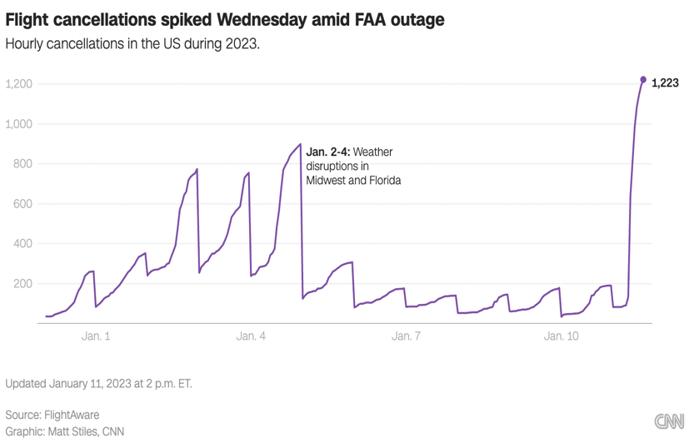

Source: FlightAware (January 11, 2023)

Located in the Western Hemisphere on the continent of North America, the United States is the fourth-largest country in the world. The conterminous United States extends 4,662 km (2,897 mi) ENE — WSW and 4,583 km (2,848 mi) SSE – NNW (Nations Encyclopedia, 2021). Air travel is the favored mode of transportation for travelers due to the topography of the United States and the often-great distances between major cities, such as for business travelers and long-distance holiday passengers. (U.S. Travel Association, 2021)

In 2021, there were 250 million domestic business trips made by travelers in the U.S. (U.S. Travel Association, 2021). As a result of the travel limitations brought on by the coronavirus (COVID-19) pandemic, domestic business travel in the United States is anticipated to fall to 181 million in 2020 (U.S. Travel Association, 2021). However, business visits are expected to increase progressively over the following years, reaching 487 million by 2026 (U.S. Travel Association, 2021). As a result, domestic travel expenditures in the U.S. reached 972 billion USD in 2019 (U.S. Travel Association, 2021). Today, the domestic tourism business in the United States substantially contributes to the economy.

"Domestic travel" refers to business and leisure travel within the same country. In the U.S., leisure travel accounts for a more significant proportion of domestic travel than business travel, and by 2024, both types of travel are projected to exceed two billion (U.S. Travel Association, 2021). National holidays are also a frequent occasion for domestic travel in the United States. For instance, the number of Americans traveling across cities increases around Thanksgiving as many visit their families. In 2020, more than 50 million Thanksgiving holiday tourists were in the United States. However, this number decreased from the previous year because of the epidemic, which limited travel opportunities nationwide (U.S. Travel Association, 2021).

Source: Statista Research Department, (2023)

In 2021, there were 250 million domestic business trips made by travelers in the U.S. The number of business visits will gradually increase over the following years, reaching 487 million by 2026. (Statista Research Department, Feb 19, 2021)

## Federal Aviation Administration (FAA):

The Federal Aviation Administration (FAA), the most prominent transportation organization in the United States, oversees all facets of domestic civil aviation and airspace over adjacent international waterways. In addition to regulating rules for airports and managing air traffic, it has the authority to safeguard American assets during the launch or re-entry of commercial spacecraft. The International Civil Aviation Organization granted the FAA sovereignty over adjacent international seas. The FAA succeeded the CAA in August 1958, eventually becoming the U.S. Department of Transportation department. (FAA.gov)

## *Primary functions: (Source:WIKIPEDIA)*

The roles of the FAA include:

* Managing U.S. business space transportation
* Operating air route offices' mathematical and flight investigation norms
* Empowering and creating common air transportation, including new flying innovation
* Giving, suspending, or disavowing pilot endorsements
* Managing standard flying to advance transportation security in the U.S., principally through nearby workplaces called Flight Norms Area Workplaces
* Creating and working an arrangement of aviation authority and route for both typical and military airplane
* Investigating and fostering the Public Airspace Framework and common air transportation
* Creating and doing projects to control airplane commotion and other ecological impacts of common aeronautics.

## NOTAM:

A NOTAM is a message that contains essential information for those involved in the flight operations but needs to be known more in advance to be made public in any other way. Changed the acronym NOTAM from Notice to Airmen to the more applicable term. Notice to Air Missions, which is inclusive of all aviators and missions.(Notice to Air Missions (NOTAMs) for Airport Operators (2022))

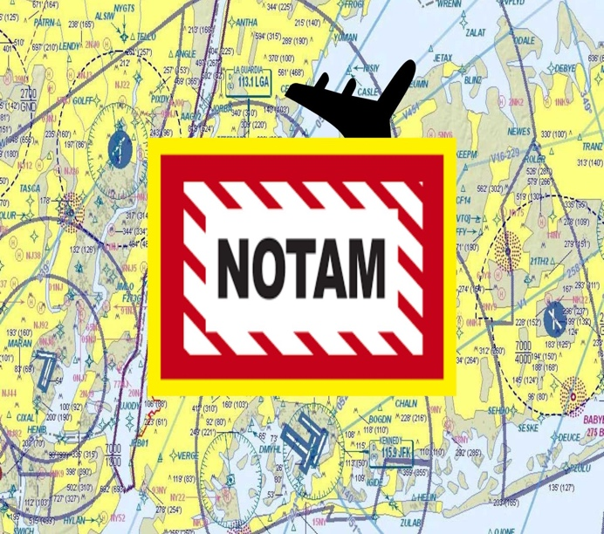

* NOTAMs are issued when a component (facility, service, operation, or danger) is established, changes, or remains the same in the NAS. In addition, they must declare that a NAS component is in an aberrant state.
* It was decided to start sending NOTAMs over telecommunications in 1947. The Notice to Mariners, which warned ship commanders of dangers when traversing the high seas, inspired NOTAMs.
* When information is predictable, aeronautical information is sent to pilots via the Airmen's Information System.
* The NOTAM system gives pilots access to temporary, time-sensitive aeronautical information that will be published on aeronautical charts later or obtained from another operational publication.
* e NOTAM is canceled when the chart displays the information or the temporary state returns to normal.
* Before the beginning of an activity, NOTAMs may be sent for up to 7 days.
* Pilots can get NOTAM data through FSS or online at https://notams.aim.faa.gov/notamSearch/.
* NOTAMs are then posted online.

## *NOTAM Contractions:*

* NOTAMs have a unique language characterized using specialized contractions.
* Contractions are imperative to the NOTAM structure because they make communication more efficient and allow computer systems to parse essential words. (Notice to Air Missions (NOTAMs) for Airport Operators (2022))
* The International Civil Aviation Organization (ICAO) is the leading authority for standardizing contractions in the international aeronautical community. If there is no ICAO contraction, plain language is used. (Notice to Air Missions (NOTAMs) for Airport Operators (2022))
* Examples such as:

|  |  |  |
| --- | --- | --- |
| CONTRACTIONS | DECODE | SOURCE |
| ABN | Airport Beacon | ICAO |
| ABV | Above | ICAO |
| ACC | Area Control Center (ARTCC) | ICAO |
| ACCUM | Accumulate | FAA |

## *NOTAM Content:*

* By 14 CFR 91.103, Pre-flight Action directs pilots to become familiar with all available information concerning a planned flight prior to departure, including NOTAMs (Notice to Air Missions (NOTAMs) for Airport Operators (2022))
* Pilots may change their flight plans based on public information
* Current NOTAM information may affect:
  + Aerodromes
  + Runway, taxiway, and ramp restrictions
  + Obstructions
  + Communications
  + Airspace
  + Changes in the status of navigational aids, landing systems, or radar service availability
  + Status of navigational aids or radar service availability
  + Hazards, such as air shows, parachute jumps, kite flying, and rocket launches
  + Flights by essential people such as heads of state
  + Military exercises with resulting airspace restrictions
  + Inoperable lights on tall obstructions
  + Temporary erection of obstacles near airfields
  + Entry of groups of birds through airspace (a NOTAM in this class is known as a BIRDTAM)
  + Notices of runway/runway/cover status concerning snow, ice, and standing water (a SNOWTAM)
  + Notice of a functionally massive change in volcanic debris or other residue tainting (an ASHTAM)
  + Programming code risk declarations with related patches to decrease explicit weaknesses
  + Other information essential to planned en-route, terminal, or landing operations

## *NOTAM Composition:*

## FAA Clarifies Function, Purpose Of NOTAMs - AVweb

## (Source:Notice to Air Missions (NOTAMs) for Airport Operators (2022))

* + From left to right
    - , the composition reads:
    - An interjection point (!)
    - Affected Location (the identifier of the affected facility or Location)
    - Keyword (one of the following: RWY, TWY, RAMP, APRON, A.D., COM, NAV, SVC, OBST, AIRSPACE, (U) and (O))
    - Accountability Location (the accountability location's identifier)
    - Surface Identification (optional—this must be the runway identification for NOTAMs related to runways, the taxiway identification for NOTAMs related to taxiways, or the ramp/apron identification for NOTAMs related to ramp/apron)
    - Condition (the condition that is being reported)
    - Time (identifies the adequate time(s) of the NOTAM condition)
* Elevation and level are in feet mean ocean level (MSL) up to 17,999; Examples include 275, 1225 (feet and MSL are not written), and in-flight levels (F.L.) for passengers over 18,000; e.g., FL550 and FL180 At the point when MSL is not known, over the ground level (AGL) will be composed (304 AGL)
* At the point when time is communicated in a NOTAM, the day starts at 0000 and closes at 2359. The NOTAM system uses universally coordinated time (UTC) and requires using ten digits (year, month, day, hour, and minute) for times. Coming up next are two instances of how the time would be introduced:
  + !DCA LDN NAV VOR OTS WEF 0708051600-0708052359
  + !DCA LDN NAV VOR OTS WEF 0709050000-0709050400

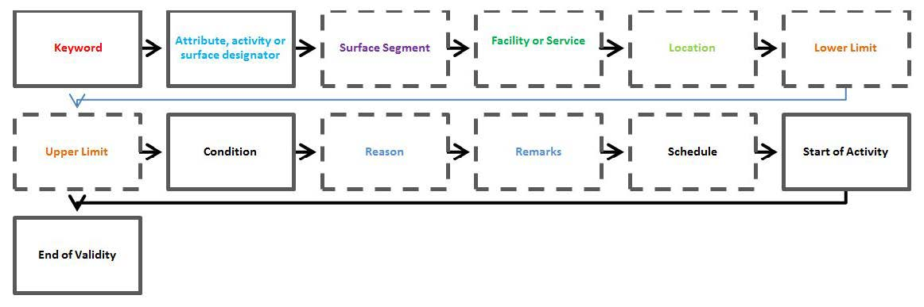

Source: Aeronautical Information Manual (AIM), FAA Order JO 7930.2, and AC 120-57.

According to FAA comments, neither SWIM nor Flight Service seems to have been involved in the failure of the NOTAM system on January 11, 2023. However, these and third-party flight planning systems that receive and disseminate NOTAM data were directly impacted by the inability to obtain or distribute current NOTAMs while the primary NOTAM system was down.

The FAA is still investigating the issue, but early signs suggest a damaged database file may have been introduced.

No evidence of a cyberattack or malevolent intent has been found thus far.

The FAA referred to the NOTAM repository as "failed antique hardware" in its FY2023 budget projection. Accordingly, it sought approximately $30 million to fund continuous modernization of the Aeronautical Information Management Program, including the NOTAM system. To speed up the FAA's multiyear endeavor to upgrade and integrate old aeronautical data systems, Congress fully funded that request and, in FY2022, approved enhanced money beyond the proposed amount.

The NOTAM system has received criticism for needing to be updated, obscure, and challenging to use and understand. The National Transportation Safety Board (NTSB) was prompted to make recommendations for more efficient ways to present safety-critical information following a near-accident in July 2017 at San Francisco International Airport, partly caused by the obscurity of NOTAM information about a closed runway.

Since then, a global initiative to update NOTAM system requirements has been undertaken by the International Civil Aviation Organization (ICAO).

The FAA Reauthorization Act of 2018 (P.L. 115-254, 394) mandated that the FAA keep improving and upgrading the central NOTAM repository and offer a web-based archive of all NOTAMs that may be searched. In addition, the Pilot's Bill of Rights Act of 2012 (P.L. 112-153) directed the FAA to establish a stakeholder.

NOTAM improvement panel and launch a NOTAM improvement program with the objectives of better tailoring NOTAM dissemination to flight plans, providing data in a format that is more usable and easier to search, and developing a publicly accessible archive built upon these requirements.

By creating a new stakeholder task force on NOTAM improvement, the Notice to Airmen Improvement Act of 2021 (H.R.,2021,1262), which the House approved in June 2021, would have required the FAA to revisit and reassess the modernization of the NOTAM system and given FAA the authority to carry out the task force's recommendations.

The House approved the Notice to Airmen Improvement Act of 2019 (H.R., 1775), a similar bill, in October 2019. In addition, both bills were discussed on the Senate floor.

Elaborated Active Design Research (EADR):

*(Referred:WIKIPEDIA)*

# The Decision

According to the preliminary FAA investigation into the NOTAM outage, contract workers accidentally deleted files while attempting to resynchronize the live primary database with a backup database. The agency has not discovered any indications of malicious intent or a cyberattack. However, the FAA continues to investigate the circumstances surrounding the outage.

The NOTAM system has been strengthened, and the FAA has made the necessary repairs. In addition, the agency is quickly implementing any additional lessons learned in our efforts to maintain the nation's air traffic control system's robustness.

1. **Continue to Use the existing system-** One option for FAA was to continue to use the current system and make no changes since the backup plan is yet to devise. This option would not add any costs. However, there would be no changes and continuation as earlier.
2. **Remove Corrupted data file-** With the implementation of corrupted data removal issues, reoccurrence can be eradicated in the future, which requires individuals with expertise to be hired not to disturb the current system while deleting the corrupted data.
3. **Improvisations**:

* Improving the communication and collaboration between FAA and airlines to minimize the impact.
* Implementing a better backup system for the NOTAM system to avoid such outages in the future and updating the system, which is 30 years old, Updated six years ago.

1. **Training**: Conducting regular training programs and drills for FAA personnel to ensure proper procedures are followed during routine maintenance results in improvising oversight and accountability.

**References**

* Bureau of Transportation Statistics (BTS)https://www.bts.gov/
* NATIONS ENCYCLOPEDIA <https://www.nationsencyclopedia.com/>
* By [Pete Muntean](https://www.cnn.com/profiles/pete-muntean),P., &  [Wallace](https://www.cnn.com/profiles/gregory-wallace),G.(2023). FAA system outage causes thousands of flight delays and cancellations across the US. <https://www.cnn.com/travel/article/faa-computer-outage-flights-grounded/index.html>
* Federal Aviation Administration’s Troubled NOTAM System Has Been on Congress’s Radar for Years (2023): https://crsreports.congress.gov/product/pdf/IN/IN12078
* Air Traffic by numbers(2022) https://cms.faa.gov/sites/faa.gov/files/air_traffic/by_the_numbers/Air_Traffic_by_the_Numbers_2022.pdf
* BYSCHUPAK,A.,(2023) FAA system outage causes mass delays and cancellations <https://flightaware.com/squawks/view/1/1_year/new/91563/FAA_System_Outage_Causes_Mass_Delays_and_Cancellations>
* Statista:https://www.statista.com/statistics/197790/us-airline-domestic-passenger-enplanements-since-2004/
* FAA OFFICIAL WEBSITE: https://www.faa.gov/
* WIKIPEDIA:https://en.wikipedia.org/wiki/Federal_Aviation_Administration
* Natural Language Processing Analysis of Notices To Airmen for Air Traffic Management:Optimizationhttps://aviationsystems.arc.nasa.gov/publications/2021/20210017786_Clarke_Aviation2021.pdf
* Notice to Air Missions (NOTAMs) for Airport Operators(2022):” [Advisory Circular (150/5200–28) Notice to Air Missions (NOTAMs) for Airport Operators](https://www.faa.gov/documentLibrary/media/Advisory_Circular/150-5200-28G-NOTAMs-2022.pdf)”
* https://www.encyclopedia.com/topic/United_States.aspx
* “NOTAMs: Back to Basics: Pilots,” *Federal Aviation Administration*,(2020):https://www.faasafety.gov/files/ notices/2019/Feb/Pilots_NOTAM_primer_1-28-19.pdf. , https://www.readkong.com/page/notams-back-to-basics-pilots-6803860
* National Transportation Safety Boardhttps://www.ntsb.gov/Pages/home.aspx
* International Civil Aviation Organization (ICAO): https://www.icao.int/Pages/default.aspx
* Burgstaller, F., Steiner, D., Neumayr, B., Schrefl,M.,& Gringinger, E., "Using a model-driven, knowledge-based approach to cope with complexity in the filtering of notices to airmen," *Proceedings of the Australasian Computer Science Week Multiconference*, 2016, pp. 1–10.
* Liddy, E.D.,(2001) "*Natural language processing,* "
* DiFlumeri, G., DeCrescenzio, F., Berberian, B., Ohneiser, O., Kramer, J., Aricò, P., Borghini, G., Babiloni, F., Bagassi, S., and Piastra, S., (2019) "Brain-computer interface-based adaptive automation to prevent an out-of-the-loop phenomenon in air traffic controllers dealing with highly automated systems," *Frontiers in Human Neuroscience*,
* Westin, C., (2017)“Strategic Conformance: Exploring Acceptance of Individual-Sensitive Automation for Air Traffic Control,” Ph.D. thesis, Delft University of Technology

# Biography



**Sindhura. A**

Prospective student at Muma College of Business keen to upgrade technical skills to prepare for the anticipated technology advances and their impact on analytics. Proven history of working in the Information and Communication Department in the Automobile industry; experienced in Analytics, Data Science, Project Management, Quality Analysis, Business Intelligence, and Supply Chain Operations.

**Sudrosh Kumar. A**

Skilled Business Development leader with six years of work experience leading operations and enhancing revenue. Bringing expertise in client acquisition and contract negotiation, excellent interpersonal communication, relationship building, and team leadership abilities. Results-driven and proactive with a demonstrated reward of accomplishment in meeting and exceeding sales and revenue objectives, including contract compliance and purchasing programs.

**Tharun. R**

He was skilled in Business analysis, design, developing code, Testing business software applications, and project implementation. Responsible for improving existing software or designing new applications, which helped rapidly increase productivity.

## Exhibit 1:

## Map Description automatically generatedAirspaces accurately represented for coverage area

**Airspace**: Federal Aviation Administration, Air Traffic Organization, Office of Performance Analysis (AJR-G).

**Airports** and **NAVAIDS**: Federal Aviation Administration, Air Traffic Organization, Airport Safety, Airport Data, and Information Portal

## Class B Airspaces (Airspace around Busiest U.S. Airports)

**Airspace**: Federal Aviation Administration, Air Traffic Organization, Office of Performance Analysis (AJR-G).

## Exhibit 2: FAA Air Traffic Management System Overview for FY2021

|  |  |
| --- | --- |
| **ATO Program and Financing**  **Operations Budget Estimate (in $billions) (FY2021)** | **$8.2** |
| **Flights Handled** | **13,028,643** |
| Scheduled | 7,014,671 |
| Unscheduled | 6,013,972 |
| **Airspace (in millions of sq mi)** | **29.4** |
| Oceanic | 24.1 |
| Domestic | 5.3 |
| **Airports** | **19,723** |
| Public Airports | 5,184 |
| Private Airports | 14,539 |
| **Federal Air Traffic Control Facilities** | **313** |
| Stand-Alone ATC Tower Facilities | 139 |
| Stand-Alone TRACON Facilities | 25 |
| Combined ATC Tower/TRACON Facilities* | 124 |
| Centers and Combined Control Facilities | 25 |
| ARTCC | 21 |
| CCFs | 4 |
| **Contract Air Traffic Control Towers**\*\* | **260** |
| **NAVAIDS** | **12,948** |
| **Alaska Weather Cameras** | **235** |
| **Controllers** | **13,850** |
| **GA Aircraft (CY2020)** | **204,100** |
| Fixed Wing | 161,600 |
| Rotorcraft | 9,700 |
| Experimental/Lightcraft/Other | 32,800 |
| **GA Flight Hours (CY2020)** | **22,492,000** |

*Combined ATC Towers and TRACONs are located within the same building.

**Includes two new contract towers introduced during FY2022.

Sources:

**ATO Program and Financing**: U.S. Dept. of Transportation, Budget Estimates: FY2022, Federal Aviation Administration, p. 2.

**Flights Handled**: Federal Aviation Administration, Air Traffic Organization, Office of Performance Analysis (AJR-G), January 20, 2022; Innovata, Flight Schedule Database, accessed March 22, 2022.

**Airspace**: Federal Aviation Administration, Air Traffic Organization, Office of Performance Analysis (AJR-G).

**Airports** and **NAVAIDS**: Federal Aviation Administration, Air Traffic Organization, Airport Safety, Airport Data, and Information Portal

(ADIP), March 14, 2022. https://adip.faa.gov/agis/public/#/airportSearch/advanced; Federal Aviation Administration, Air Traffic Organization, Technical Operations (AJW), Facility Service and Equipment Profile, October 5, 2021. https://employees.faa.gov/org/linebusiness/ato/operations/technical_operations/ajw1/ajw1B/fsep/

***FAA NOTAM SEARCH PUBLIC PAGE:***

Sources:

<https://notams.aim.faa.gov/notamSearch/nsapp.html#/>

https://www.faa.gov/about/initiatives/notam/what_is_a_notam/media/Pilots_NOTAM_primer_for_2021.pdf